# **Caremark.com - Member Log In Website**

|  |
| --- |
| **Scenario/Member Statements** |

I'm logging in and I am getting a screen that says "Just need to confirm it's you" what do I do?

I created an account but am unable to sign in, can you help?

 **Notes:**

* Access Caremark.com and go to the Profile page (regardless of registration status shown from Compass) to confirm registration and verify member is using the correct username
* Confirm the member is trying to sign in on Caremark.com (not CVS.com, CVSHealth App, or CVSSpecialty.com.
* Check the client CIF to confirm client is not SSO only.

|  |
| --- |
| **Member Signing In From Recognized Device** |

1. Click on sign in.

1. Enter username and password.

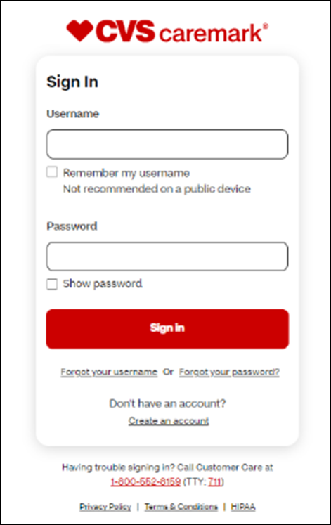

1. Member will be logged into Caremark.com.

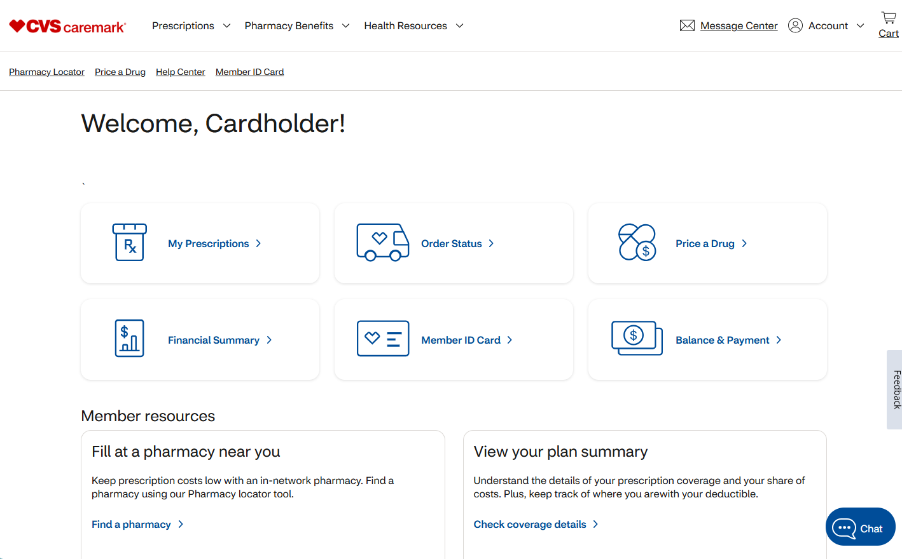

|  |
| --- |
| **Member Signing in From Unrecognized Device** |

If the member is signing in from an unrecognized device, the member will be required to confirm their identity and request a verification code be sent to their email or mobile phone number on file via text message.

1. Choose and click send.

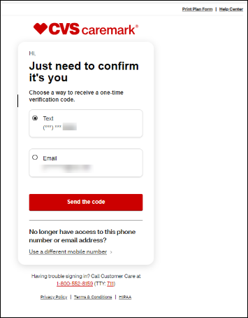

1. Choose and confirm.

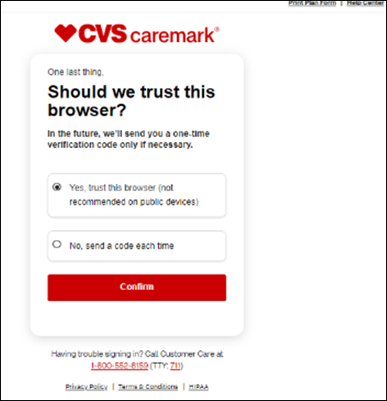

1. Enter code received and confirm.

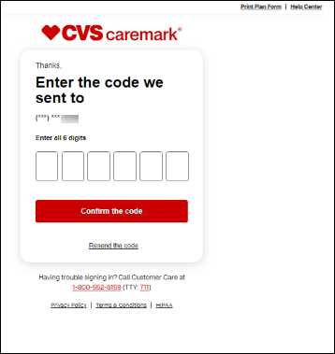

1. Member will be logged into Caremark.com.



|  |
| --- |
| **Related Documents** |

[Caremark.com - Common Member Assistance Call Types Index](https://thesource.cvshealth.com/nuxeo/thesource/#!/view?docid=947b0b38-401d-4b18-a08e-60348558a9b9)

[Caremark.com – Troubleshoot Member Login](https://thesource.cvshealth.com/nuxeo/thesource/#!/view?docid=422c7044-7196-4ed4-a10a-8037b579a4a9)

**Full Details Document:**  [Caremark.com and Mobile Web – New Log In/Multifactor Authentication (MFA)](https://thesource.cvshealth.com/nuxeo/thesource/#!/view?docid=fb037e34-deba-4d00-af22-d401e0394aab)

Not To Be Reproduced Or Disclosed to Others Without Prior Written Approval

**ELECTRONIC DATA = OFFICIAL VERSION / PAPER COPY = INFORMATIONAL ONLY**